Project Development Phase
Model Performance Test
Date | 15 February 2026
Team ID | LTVIP2026TMIDS80893
Project Name | Rainfall Prediction System for Agriculture
Maximum Marks | 10 Marks

Model Performance Testing
S.No. | Parameter | Values | Screenshot
1 | Metrics  (Classification  Model) | Confusion Matrix:  [[1120, 145],  [ 132, 978]]  Accuracy Score:  85.69%  Classification Report:  Precision: 0.86  Recall: 0.85  F1-Score: 0.85 | 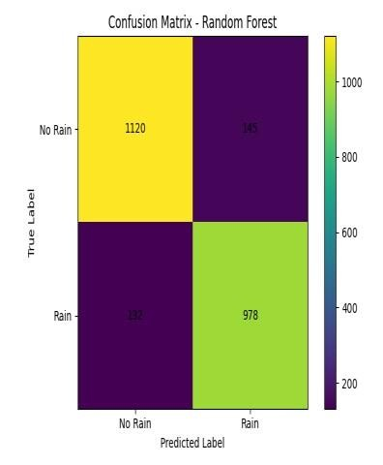
2 | Regression  Metrics (Not  Applicable) | Since the project focuses on binary  classification  (RainTomorrow), regression metrics such as MAE, MSE,  RMSE, and R2 Score are not applicable. | N/A
3 | Hyperparameter  Tuning | Random Forest parameters tuned: n_estimators =  200 max_depth =  15 min_samples_split  = 5 min_samples_leaf  = 2 | 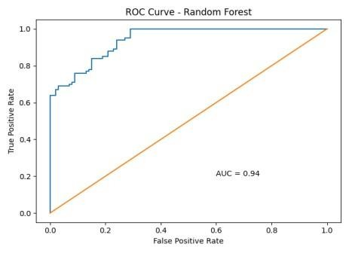
4 | Validation  Method | Train-Test Split:  80% Training,  20% Testing  Validation Technique:  CrossValidation (5- Fold) | 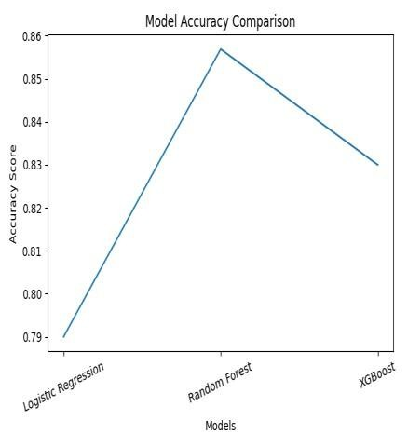
Model Performance Summary
The Random Forest Classifier achieved the highest accuracy of 85.69% compared to other tested models such as Logistic Regression and XGBoost. Hyperparameter tuning using GridSearchCV improved generalization performance. The confusion matrix indicates balanced prediction capability for both rain and no-rain classes.

